

Telling java that we need some new space store a value of type integer.



**Memory Model**



This box represents the space that will represent the variable and label this box with the name of the variable.



**Variable Assignment**



52 is put in the box which is labeled as var1

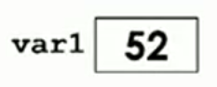

Value if var1 will be copied and placed in var 2

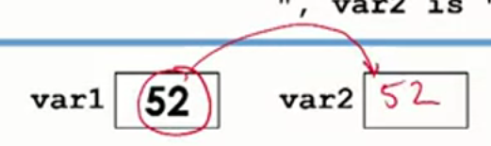

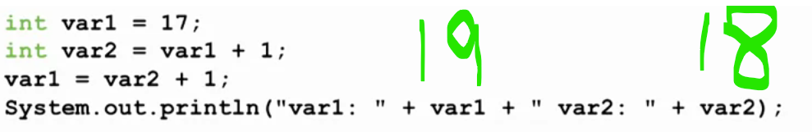



**Put the code in class IntAssignmentTester**

**public class IntAssignmentTester**

**{**

**}**

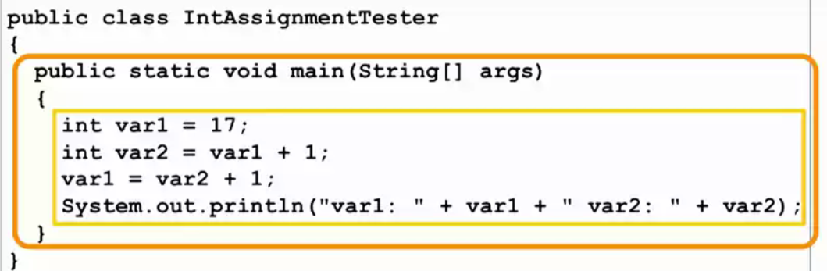

**Java has two kinds of data**

**1)Primitive kind of data**

**Example:**



**2)Object**

Arrays are objects, classes are objects

ucsd is object type variable







**When we write**

new Name_of_classs(argument_one_value, argument_two_value);

We are creating new object and java allocates some space in computer memory to store that object



Hence object is created in part of computer’s memory called heap and object is put at some location in the heap that location has some address, hence the newly created object is at some specific location inside heap.

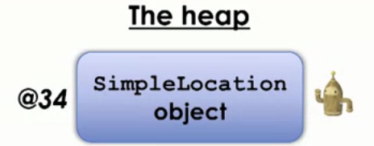



The entire object is not placed inside the for ucsd box, rather reference to(location of ) that object in the box for ucsd

Hence value stored in the ucsd is nothing but the location of the object

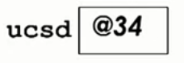

Or

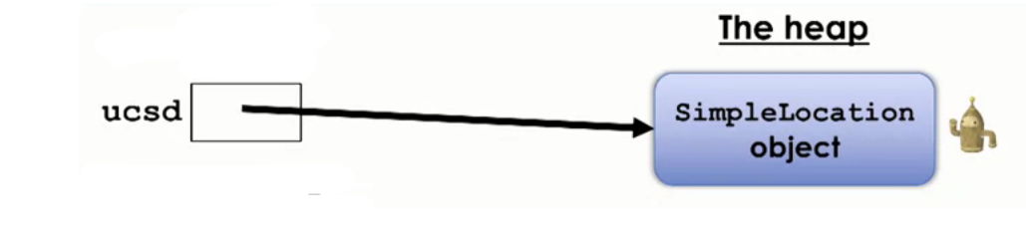

This arrow represents the location or reference to the object wherever that object is stored in the heap.

Our class has two member variables hence those member variables will be stored inside the object

The newly created object inside heap at some location will look something like

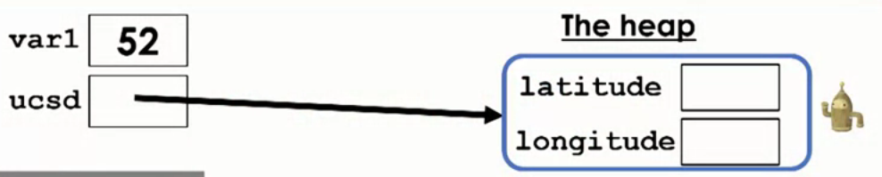

Hence box for each member variable is created and label them according to the name of member variables, these boxes are going to store values(from constructor

The values that get passed in go to latitude and longitude variables inside object



) when object is created

Similarly for



Lima is object type variable which stores the address of newly created object.

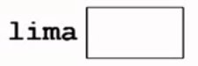

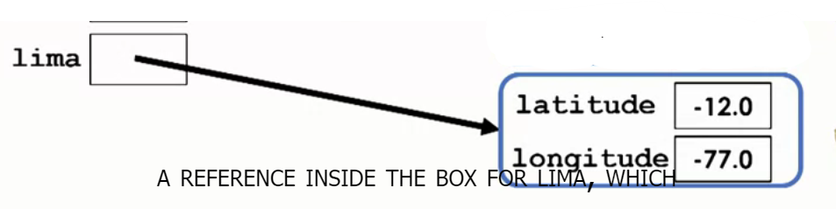

This changes the value of latitude inside the variable lima



Follow from the location of object (lima) to the object to find variable latitude inside the object

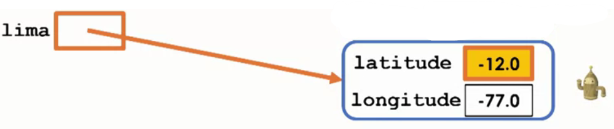

Then the value gets updated

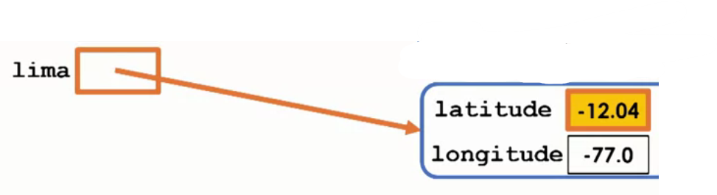

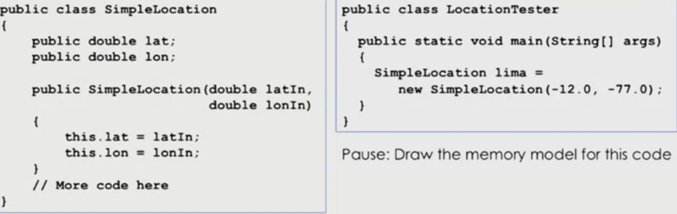



**Variable Scope:**

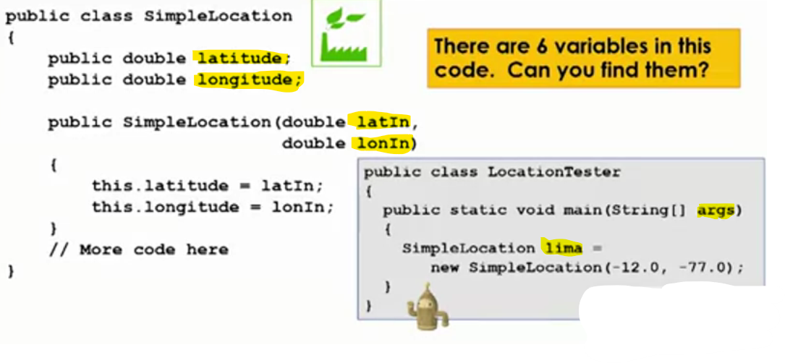





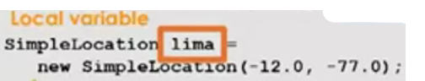

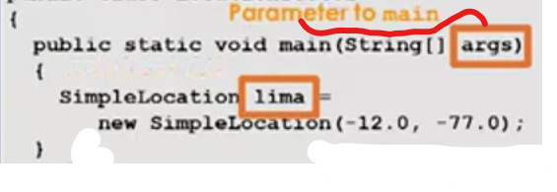

public class SimpleLocation

{

//variable declared in SimpleLocation class

  public double latitude;

  public double longitude;

  public SimpleLocation(double latIn, double lonIn)

  {

    this.latitude = latIn;

    this.longitude = lonIn;

  }

  //More code here

  }

public class LocationTester

{

  public static void main(String[] args)

  {

    SimpleLocation lima = new SimpleLocation(-12.0, -77.0);

    // new line we're testing

//Using variable declared in SimpleLocation class inside main method will cause compilation errro

    latitude = 12.04;

  }

}

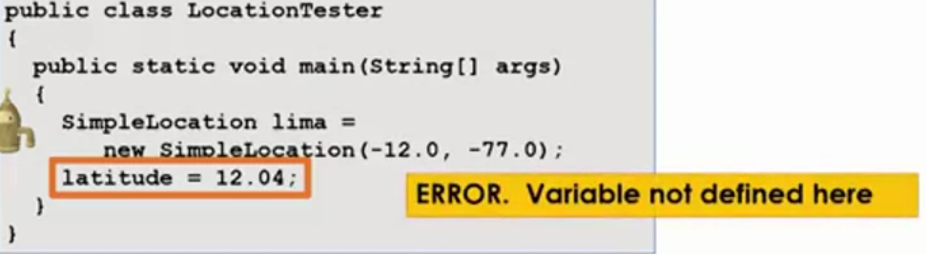

**Local variables:**

**Lima is local variable:**

**Parameters**



Arguments that get passed into methods.

Use them anywhere inside methods, change their value

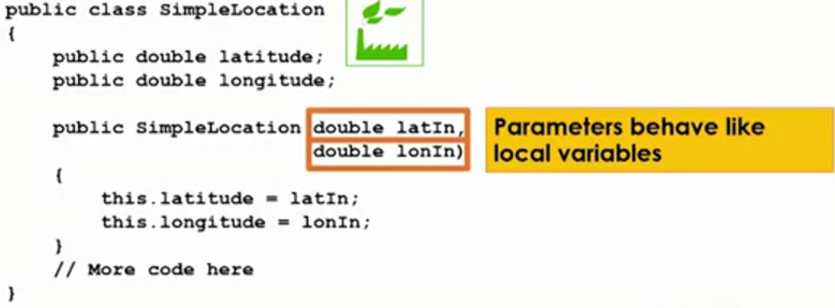

Member variables are variables that belong to class, their scope is entire class



Variable lat only exist inside the scope of main methods

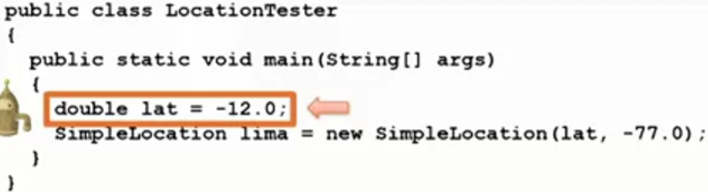



Lima is object type variable(store the location(reference to) of newly created object gets created in heap (separate part of memory)



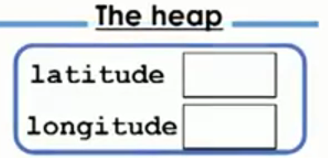the two member variables gets placed inside object, latitude and longitude are not inside main scope but rather they are in the scope of object, when the constructor gets called

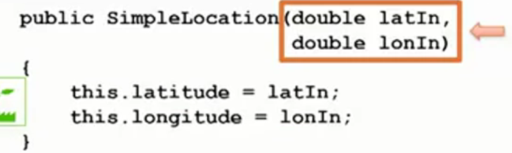

**Parameters gets instantiated, parameters have their own scope which is local to the constructor.** 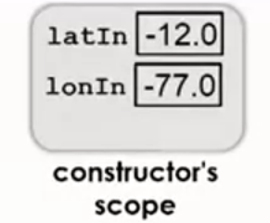

and only exists inside the scope of main methods

This stores the object reference(location) we created

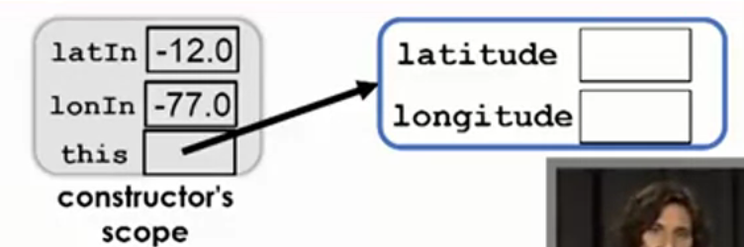

This key word can be omitted or optional

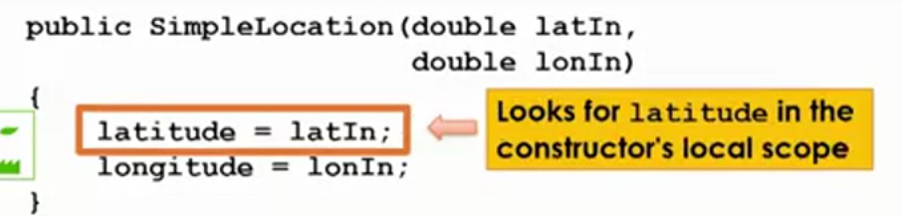

Java will first look for latitude and longitude inside constructor , if it doe not find them then it will look for latitude and longitude in the calling object

and finds the longitude and latitude

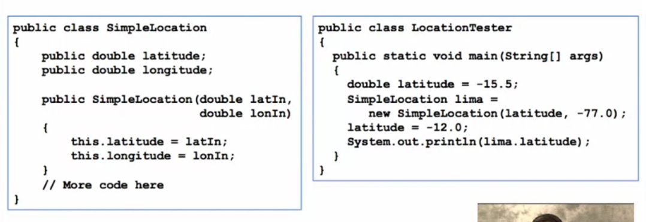



-15.5,-77.0

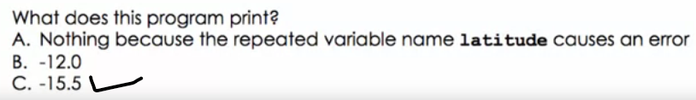

public class SimpleLocation

{

    public double latitude;

    public double longitude;

    public SimpleLocation(double latIn, double lonIn)

    {

        this.latitude = latIn;

        this.longitude = lonIn;

    }

}

public class LocationTester

{

    public static void main(String[] args)

    {

        double latitude = -15.5;

        SimpleLocation lima = new SimpleLocation(latitude, -77.0);

        latitude = -12.0;

        System.out.println(lima.latitude);

    }

}





The lima variable stores the location of newly created object

newSimpleLocation(late,-77.0) is going to call the constructor and pass the values

    public SimpleLocation(double latIn, double lonIn)

    {

        this.latitude = latIn;

        this.longitude = lonIn;

    }

And also created the new object in the heap

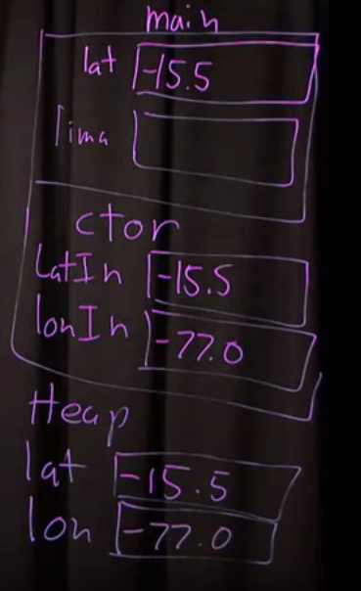

lat=-12

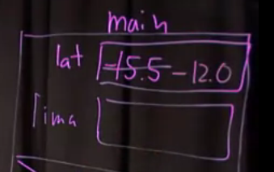

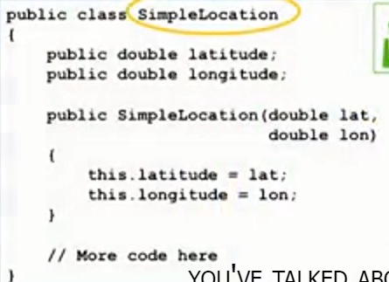

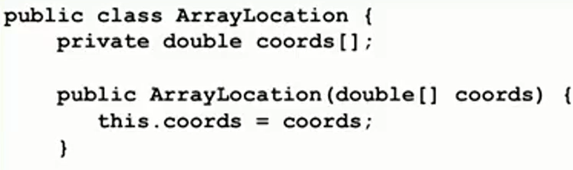



32.9



Coords variable stores reference or location of an array (an object) created in heap, hence scope of coords array is heap, coords array only exists in heap as array is object data type not primitive type.

Array is not primitive type , it object type

